Linux Capability Exploration Lab

Extra Credit Assignment for CS5460

Austin Derbique A01967241s

This is a Medium Seed Lab. The seed Lab can be found here: http://www.cis.syr.edu/~wedu/seed/Labs_12.04/System/Capability_Exploration/

2.1 Install Libcap
I installed libcap from the terminal. Screenshot here:
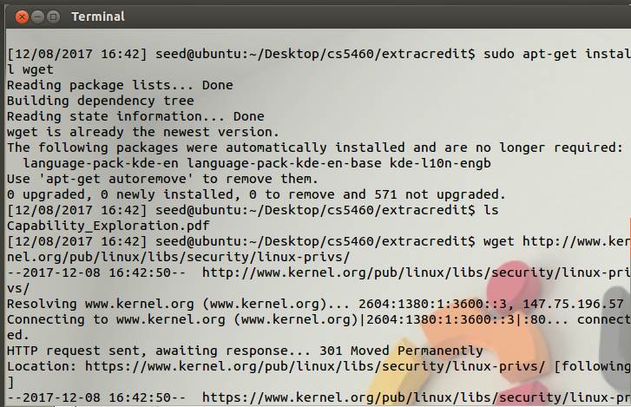
  - Put SELinux in Permissive Mode
My distrobution of Ubuntu does not have SELinux which means I can skip this part. That is what the lab says to do.
3 Lab Tasks
  - Task 1: Experiencing Capabilities
This part discusses how the program ping is a SetUId program, meaning that the system changes the user to root to run the program. If there are any vulnerabilies with ping, the entire system can be compromised. This is a screenshto of changing the program to a non setuid program.
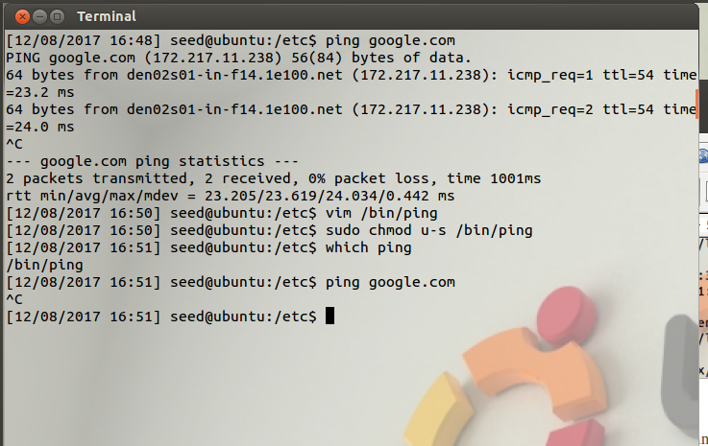
Although it is not a setuid program, we can use setcap to change the /bin/ping to be allowed to have cap_net_raw capability without the setuid power. This is seen below:
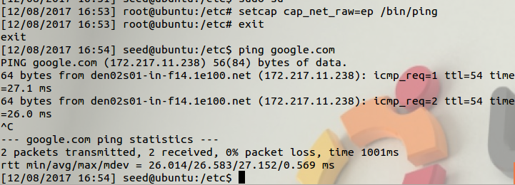
Question 1: Please turn the following set_uid programs into non-set-uid programs without afecting the behaviors of these programs: /usr/bin/passwd
To solve question one, these are the commands I executed:
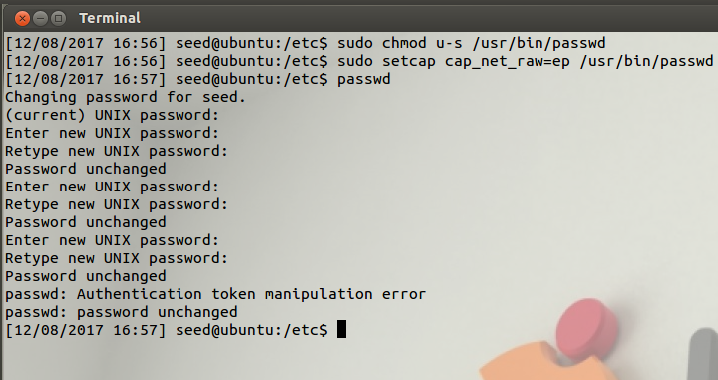
Question 2: Explain the purpose of this capability.
- cap_dac_read_search – reads the capabilities of the program
- cap_dac_override – Overrides the default cap permissions
- cap_chown – Changes the ownership capabilites
- cap_setuid – changes the user ID to something else
- cap_kill – kills all capabilities for the program
- cap_net_raw – enables the raw socket for the capabilities

3.2 Task 2: Adjusting PrivilegesThis task asks to run the followin commands to compile and install the updated libcap. I updated libcap here:
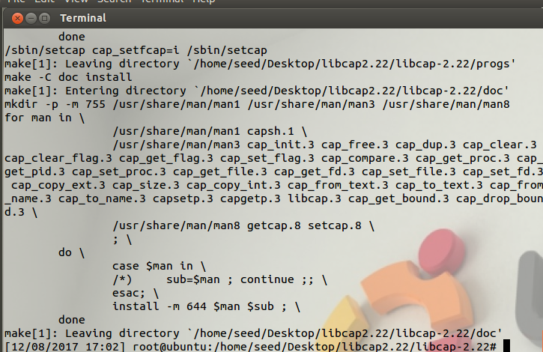

Question 3. Compile the following program and assign the cap_dac_read_search capabilit to the executable. Login as a normal user and run the program. Descrive and explain your observations.

The name of this file is use_cap.c located in the main directory.
Compiling the code:
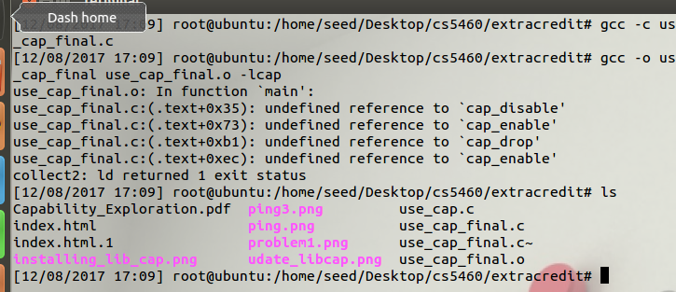
The code itself:
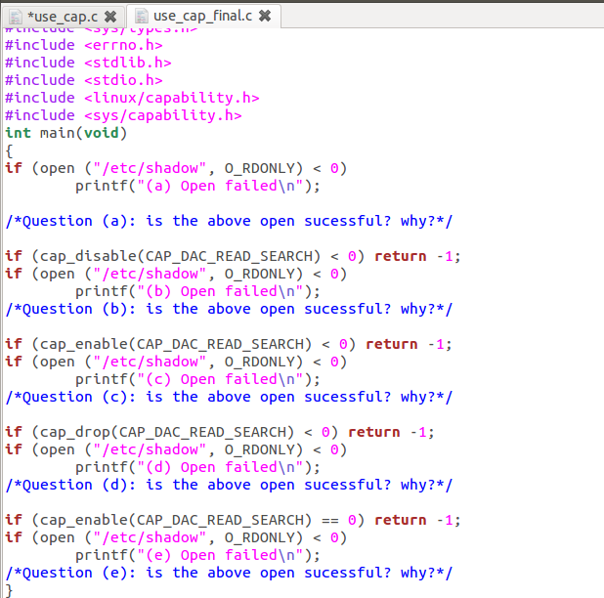

a. It's interesting. It was not able to open the shadow file unless you gave it root permissions from the setuid.
b. This failed as well
- This one successful. Because cap_dac_read_search was true.
- This was also successful because cap_dac_read_search is now true
e. With cap_enable true, the shadow file successfully opened here as well.
Question 4: If we want to dynamically adjust the amount of privileges in ACL-based access control, what should we do? Compared to capabilities, which access control is more convenient to do so?
It seems the most convenient method is to use a SetUId for the program, but that is not nearly as safe. You'd better off use the use_cap to handle capabilities for a given program.

Question 5. After a program (running as normal user) disables a capability A, it is compromised by a buffer-overflow attack. The attacker successfully injects his malicious code into this program's stack space and starts to run it. Can this attacker use the capability A? What if the process deleted the capability, can the attacker uses the capability?
They may be able to run the code.. but it will not do anything as the capability is gone. This means that the attacker has no power to do anything with that system. The attacker can only use the process if there is a capability there.

Question 6. The same as the previous question,except replacing the buffer overflow attack with the race condition attack. Namely, if the attacker exploits the race condition in this program, can he use the capability A if the capability is disabled? What if the capability is deleted?
This one would seem to work better than the buffer overflow attack as the race condition attack will be performing two or more operations at the same time. If the capability is disabled, there is more than one process so one will still remain. This means that the attack can still be carried out.

